User Manual

Online Restaurant Management Program

Adrian LaCour

Damien Wiggins

Michael Cooper

Anderson Adams

Greg Faaborg

Dania Chavez

Cultured

Table of Contents

Introduction 2

User login activity 3

Customer layout activities 4

Customer main menu 4

Customer menu layout 5

Customer payment layout 6

Customer game window 7

Kitchen staff layout activities 8

Kitchen staff layout 8

Wait staff layout activities 9

Wait staff layout 9

Manager layout activities 10

Manager action menu 10

Manager menu layout 11

Manager sales layout 12

Manager staff layout 13

Manager Table layout 14

# Introduction

This user guide will walk you through a sample user interface of the Cultured restaurant management system. The Cultured restaurant management system allows the manager of record to oversee the status of tables, customer orders, and restaurant staff. The Cultured system will also allow customers to place orders from and submit payment to the restaurant. The Cultured restaurant management system separates the roles of the customer, wait and kitchen staff, and manager, by permissions: the manager will have the most permissions, followed by the wait staff, kitchen staff, and customer. The Cultured restaurant management system is simple, sleek, and functional.

# User login activity

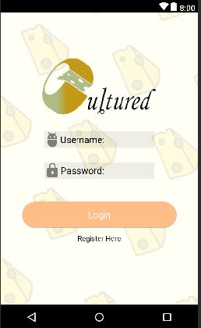

Based on login information entered, the user will be sent to activity based on position customer, staff, and manager that is associated with their login. This will happen after Loginis selected.

# Customer layout activities

## Customer main menu

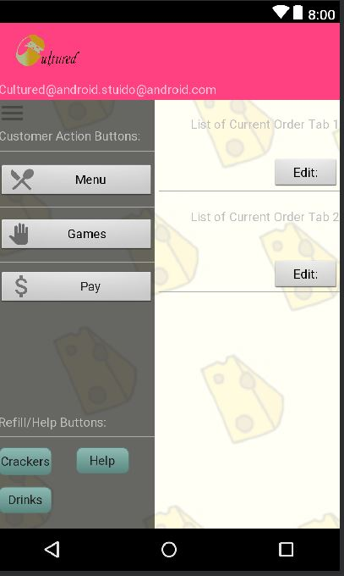

The left side consists of a drawer that will take the customer to another activity. This includes the menu, games, and payment.

More buttons are available in the bottom of the drawer that will send signals to the wait staff and only give the customer a toast at the bottom of the screen indicating that the signal has been sent.

On the right side of the screen the list of tabs and orders for each tab will be listed with a button allowing the customer to edit the orders.

## Customer menu layout

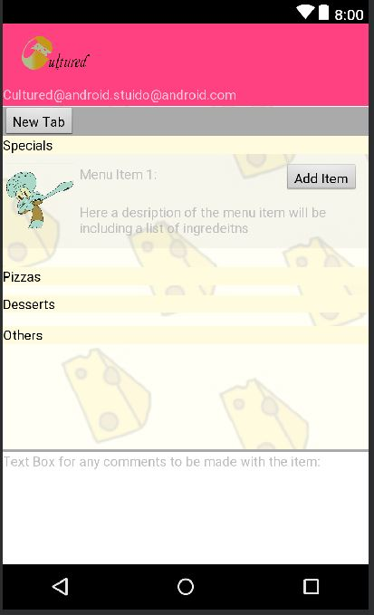

The menu will list categories of items and then hold menu items inside. Each item has a picture of the item, a name, and a description. Beside each item is a button that will allow the customer to add the item to the current order.

## Customer payment layout

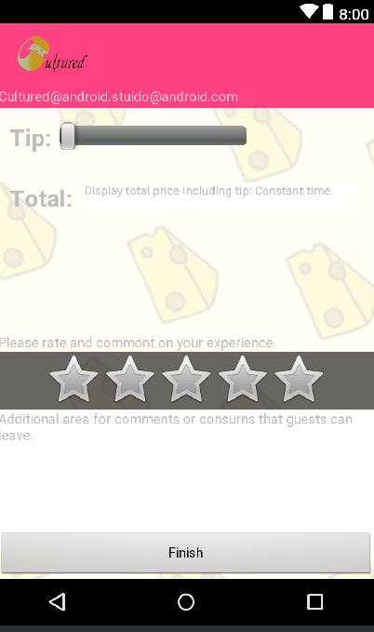

The customer payout will include a tip slider that will increase the total amount, shown below, at every percentage.

At the bottom of the window, the customer will be able to rate their experience, out of 5 stars, and supply any comments that they would like.

## Customer game window

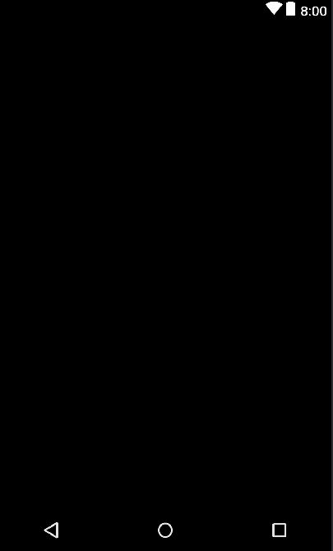

Games currently doesn't exist, but this window will load list of games and play them when clicked.

# Kitchen staff layout activities

## Kitchen staff layout

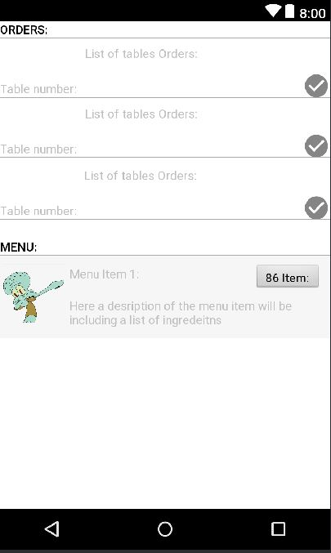

Orders will be listed here, along with the table number for each order. Beside each order, the kitchen staff can select the ready button. This will notify the waitstaff that the order for table is ready.

Below the list of orders, a list of menu items is given where the kitchen staff can make any of the 86 items unavailable to be ordered, if they have run out of ingredients.

# Wait staff layout activities

## Wait staff layout

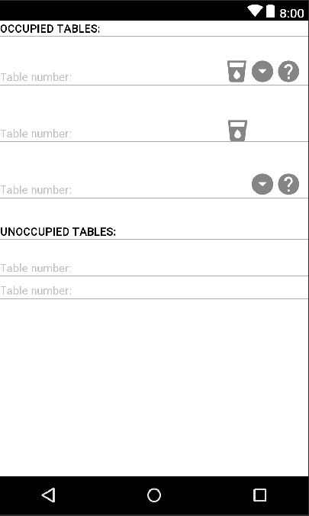

The waitstaff will have a list of tables available, where each table will have 4 icons that appear. These icons will show that the tables need drink refills, cracker refills, help, or if their food is ready.

# Manager layout activities

## Manager action menu

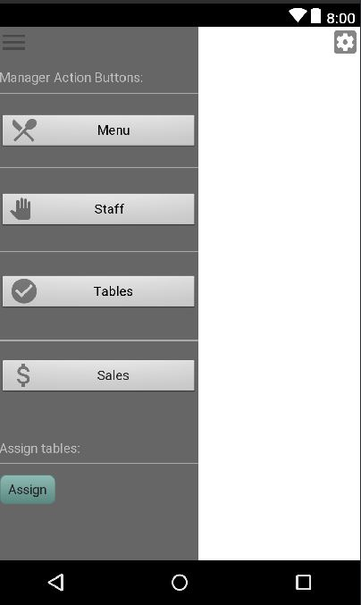

This menu will allow the manager to access the menu, list of staff, list of tables, list of sales, and assign tables.

## Manager menu layout

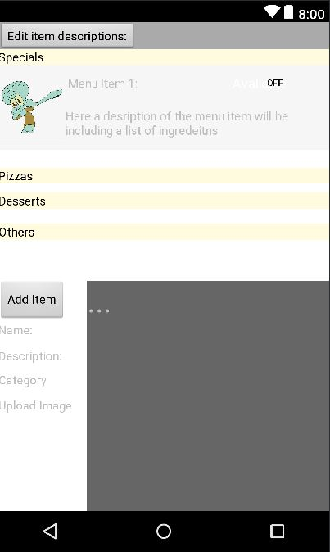

The menu layout will ensure that the list of menu items is available to the manager. The manager can turn off the menu item, edit any information for each item, and add new menu items.

## Manager sales layout

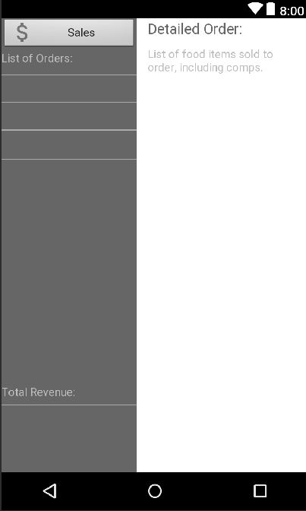

The sales layout will display the list of orders that have been placed throughout the day. It will also show the total revenue to the bottom-left of the screen. When an order is selected, a detailed list of the order will be displayed to the right, which includes all menu items sold and the comps given.

## Manager staff layout

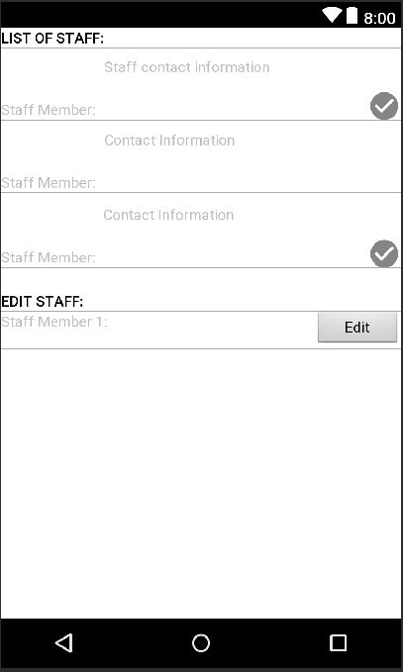

The staff menu is a separate activity for the manager, where a current list of staff is given, with the staff member name, contact information, and symbol that indicates if they are currently clocked in. After the list of staff, there is another list of staff, where the manager can edit the staff information.

## Manager Table layout

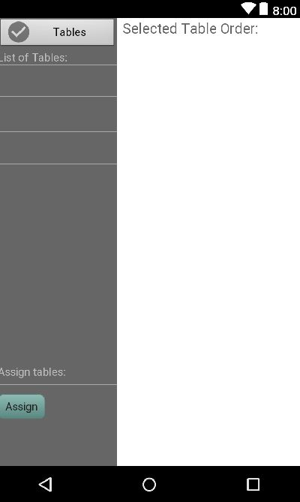

The table layout is where the menu turns into a list of tables, and underneath the manager can assign a new table. After selecting the table, the current order of the table will be listed to the right.